1. What is scope?

2. What are the 3 different levels of scope?

1.

2.

3.

3. What is wrong with the following code snippet?

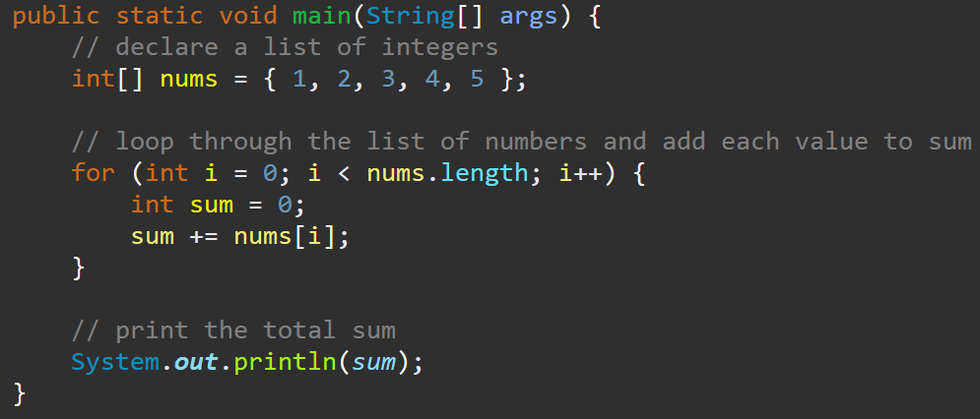

4. Given the following code, identify the scope of each variable:

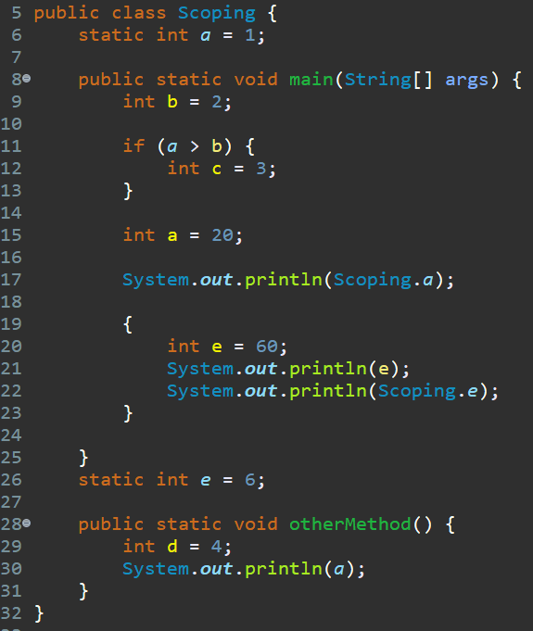

a (line 6): _____________

b: ______________________

c: ______________________

a (line 15): ____________

d: ______________________

e: ______________________

5. Given the following code snippet, which line represents the ***best place*** the variable nextNum should be declared?

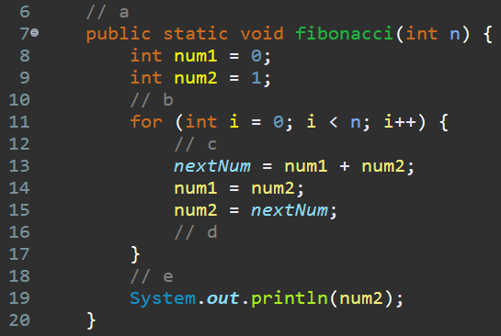

a. line 6

b. line 10

c. line 12

d. line 16

e. line 18